1. Draw the V-Model diagram on paper or using any digital tool, and clearly label each phase with both the developer and tester roles involved at each step.

ANSWER:-
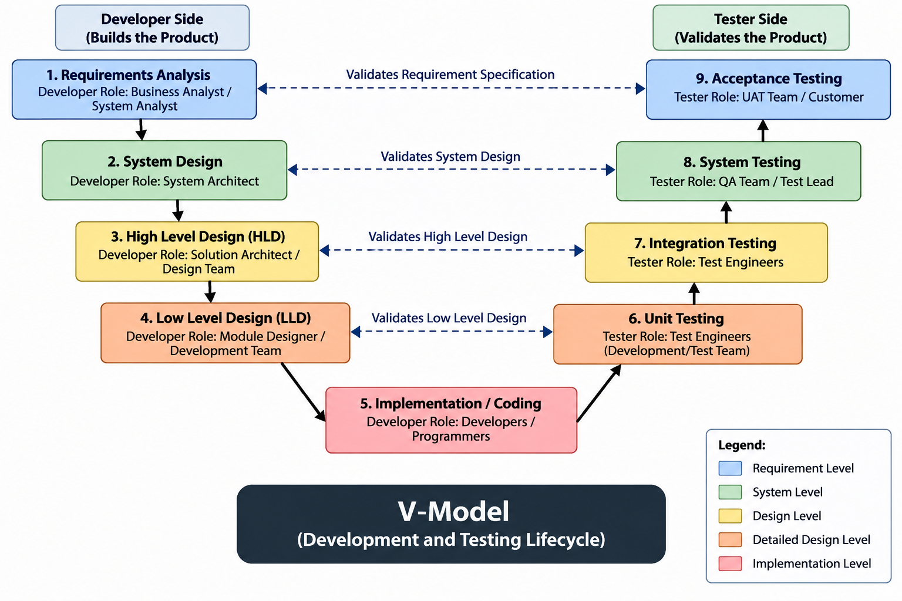

2. Pick any app you use daily (like Zomato, Instagram, or Paytm) and write a short table mapping each SDLC phase (Requirement, Design, Coding, Testing, Deployment, Maintenance) to a real activity that would happen for that app.

ASNWER:-
SDLC Phase | Real Activity (Zomato)
Requirement | Business analysts identify that users want to see their delivery partner's live location on a map instead of just a status text like "Out for delivery."
Design | UX designers wireframe the map screen with a moving bike icon; architects design how the delivery partner's GPS coordinates will stream to the app in real time.
Coding | Developers write the backend logic to receive and broadcast GPS pings from the delivery partner's app, and the frontend code to render the live map and ETA.
Testing | QA engineers test that the location updates smoothly, the ETA recalculates correctly if the rider takes a detour, and the feature works on weak network/low-end phones.
Deployment | The tracking feature is rolled out to production servers and released to a small % of users first (phased rollout) before going to everyone on the App Store/Play Store.
Maintenance | Team fixes bugs like "map freezes near tunnels," improves GPS accuracy, and optimizes server load during peak dinner-hour traffic.

3. For each phase of the V-Model, list one specific testing activity that should be performed, using examples from a food delivery app (like Swiggy or Zomato).<br><br><em><strong>Hint:</strong> For example, during 'System Testing', you might test if the order placement works end-to-end.</em>

ANSWER:-
V-Model Phase | Validates | Specific Testing Activity (Swiggy example)
Requirements Analysis | User requirements | Review that a requirement like "user must get delivery within 45 minutes or a refund" is written clearly enough to actually be tested later.
System Design | System requirements | Check the system design ensures the payment gateway, restaurant app, and delivery-partner app can all sync order status in real time.
High-Level Design (Architecture) | Module interactions | Prepare integration test scenarios for the flow: order placed → payment → restaurant confirmation → delivery partner assigned.
Low-Level Design (Module Design) | Individual functions | Design a unit test case for the "calculate delivery fee by distance" function, before it's even coded.
Coding | Code correctness | As the code is written, run a quick unit check that the promo-code discount function correctly reduces the bill for a ₹300 Paneer Butter Masala + naan order.
Unit Testing | Low-Level Design | Formally test the bill calculation function in isolation — confirm tax + promo discount math is correct for that same order, without running the full app.
Integration Testing | High-Level Design | Verify the Cart module correctly checks the Restaurant Inventory module to confirm naan is actually in stock before checkout is allowed.
System Testing | System Design | Run the complete end-to-end flow: search restaurant → add Paneer Butter Masala + naan to cart → apply promo code → pay → track delivery → receive order.
Acceptance Testing | Requirements Analysis | Have a pilot group of real users place live orders to confirm the tracking screen is intuitive and the 45-minute delivery promise is actually met.

4. Compare the V-Model and RAD Model by listing 3 strengths and 2 weaknesses of each, focusing on how testing is handled in both models.

ANSWER:-

Model | Strengths (Testing) | Weaknesses (Testing)
V-Model | Proactive test planning: Test cases are written alongside each development phase (e.g. acceptance tests are planned during requirement analysis, not after coding). | Late execution: Even though testing is planned early, actual test execution only happens after coding is complete so fundamental design flaws surface very late.
 | Structured traceability: Every testing level (unit, integration, system, acceptance) maps directly to a specific design phase, so a defect can be traced straight back to its root cause. | Inflexible test assets: If a requirement changes mid-project, the test plans and documentation for every phase built on top of it usually need to be rewritten.
 | Clear entry/exit criteria: The strict, sequential structure means incomplete or unverified code can't move forward to the next stage, keeping quality gates strong.
RAD Model | Continuous user validation: Real users test actual working prototypes throughout development, not just a final build so feedback reflects real usage, not just a spec. | Heavy reliance on user availability: The whole testing approach depends on users being consistently available to review prototypes; if they're not, the cycle stalls.
 | Early defect detection: Because prototypes are built and shown quickly, logic and usability bugs are caught and fixed almost immediately instead of piling up. | Minimal test documentation: The speed of iteration often means testing is done informally, with little written down making regression testing later much harder.
 | Incremental, manageable testing: Testing is broken into small chunks per iteration rather than one massive test phase at the end, reducing overall risk and pressure.

